LINKED PROFILE

<https://www.linkedin.com/in/harvey-marakalala-906b78250/>

Peer Evaluation

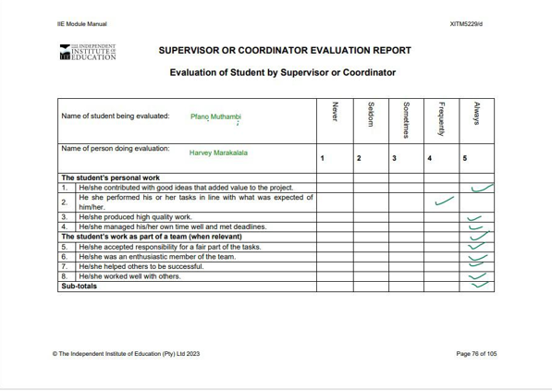

Peer Evaluation 2

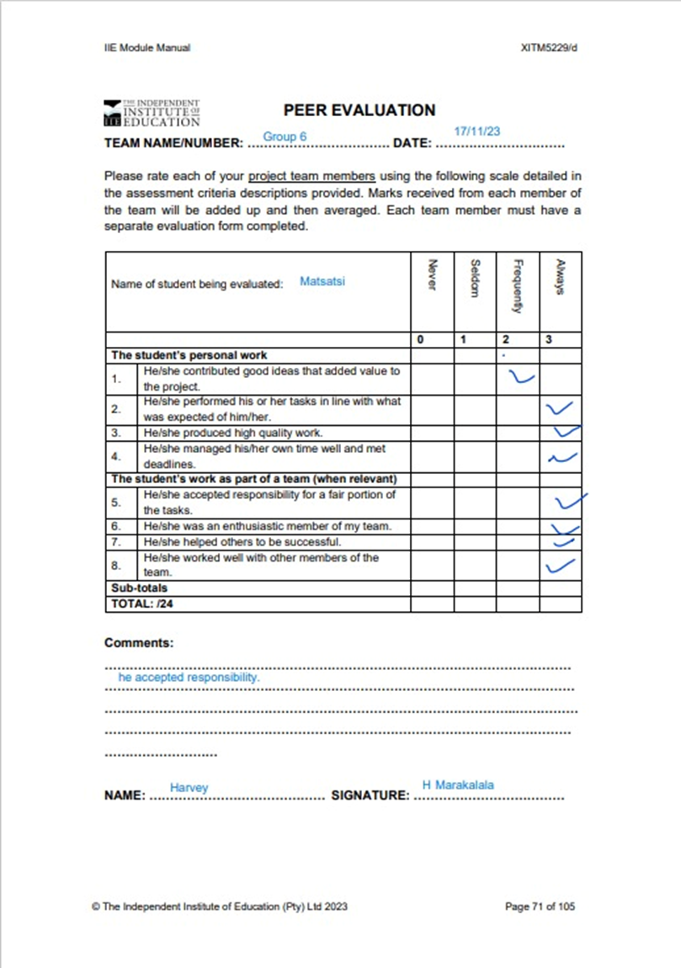

LORAX

11/11/24

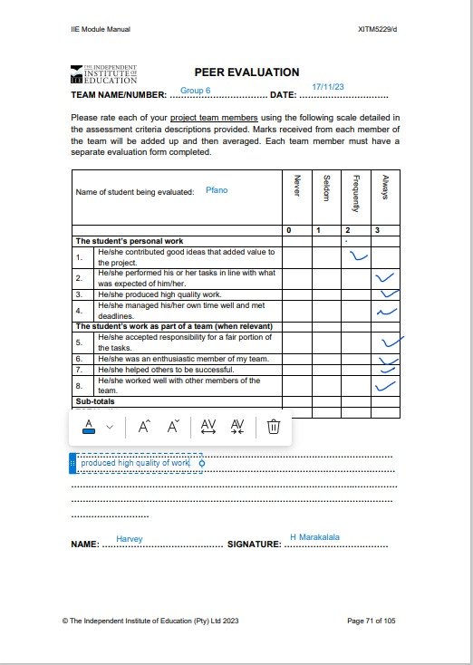

LORAX

11/11/24

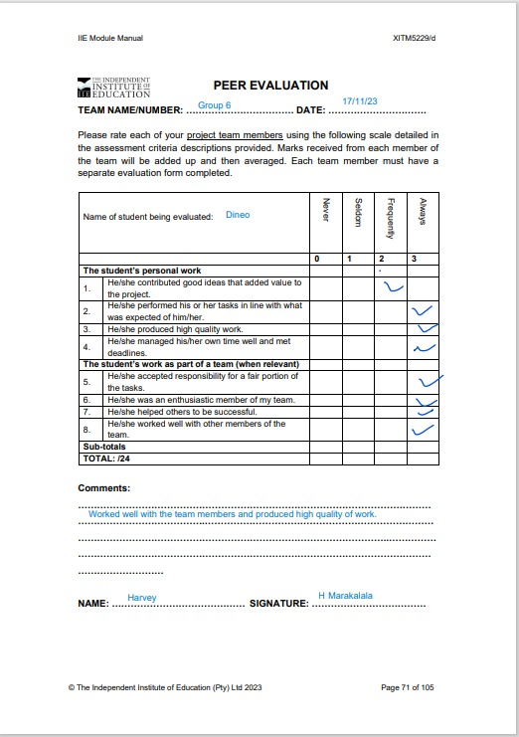

11/11/24

LORAX

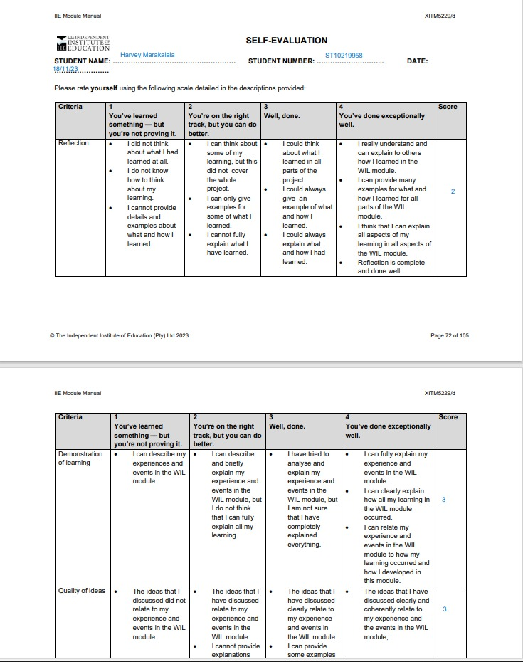

11/11/24

11/11/24

11/11/24